GIT AND GITHUB 02

1)Install git.

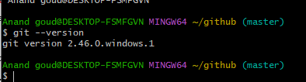

2)Create a repo in github with README.md and .ignore file.

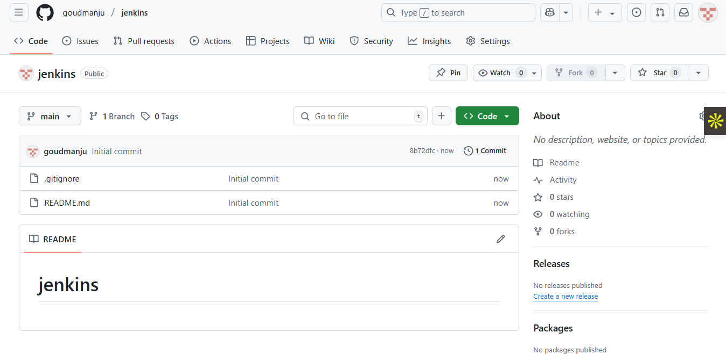

3)Clone the created repo to local.

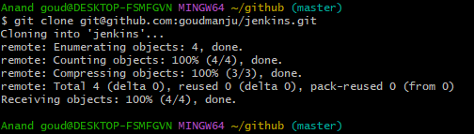

4)Create two files in local repo.

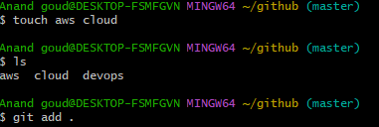

5)Commit two files and push to central Repository.

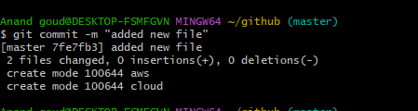

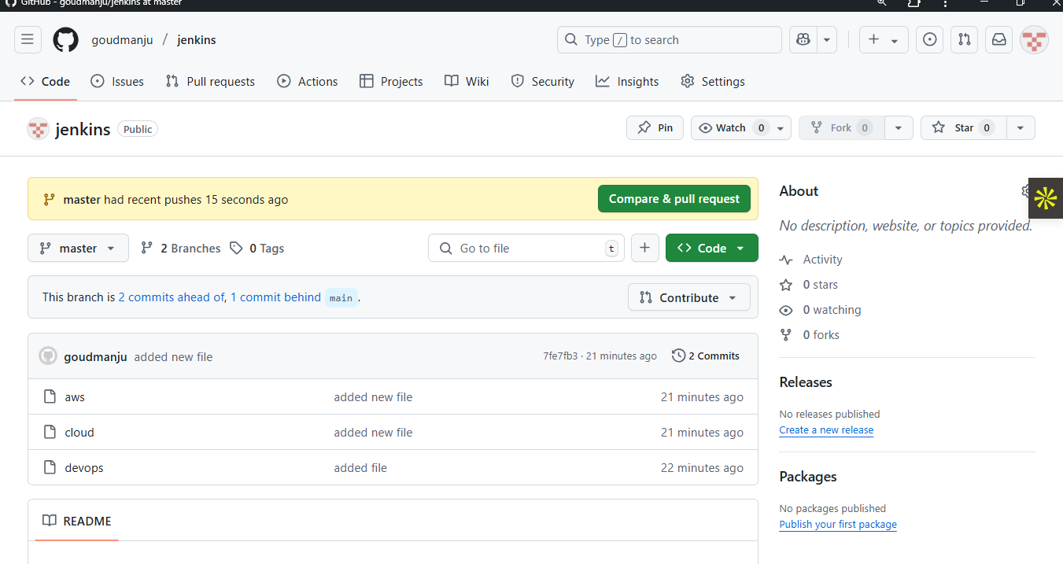

6)Create a branch in local and create a sample file and push to central.

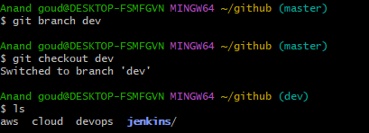

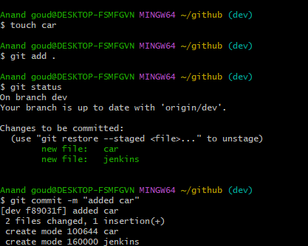

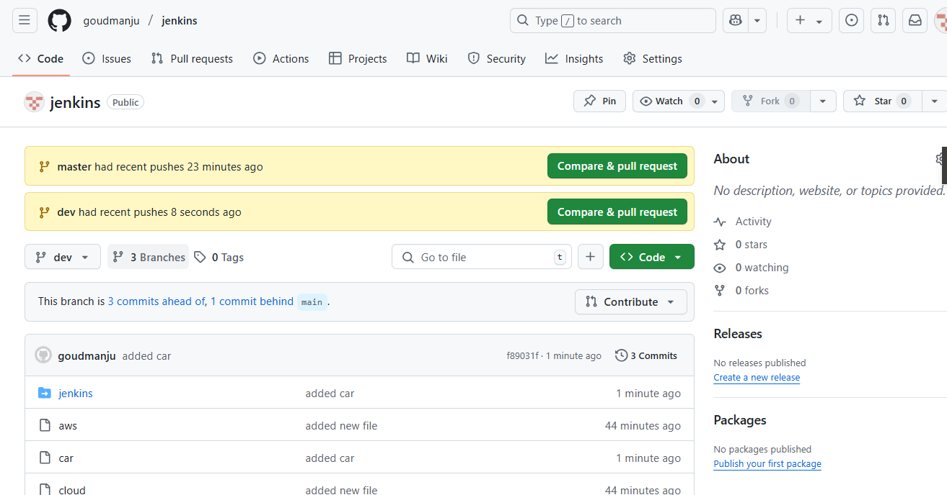

7)Create a branch in github and clone that to local.

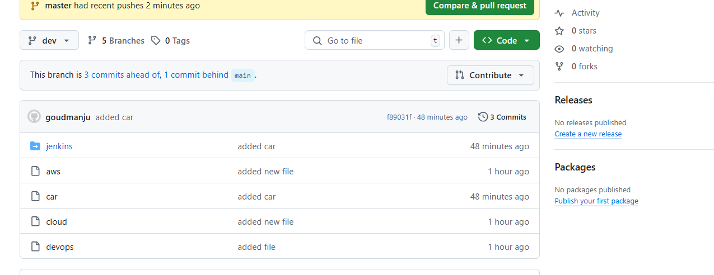

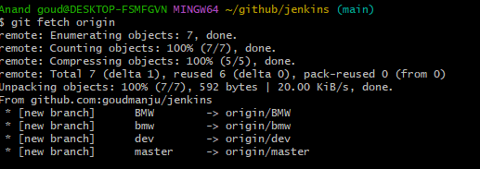

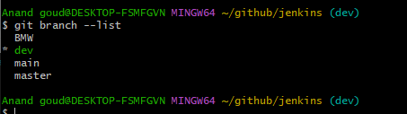

8)Merge the created branch with master in git local.

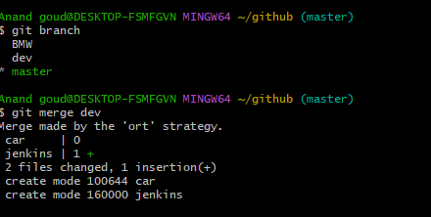

9)Merge the created branch with master in github by sending a pull request.

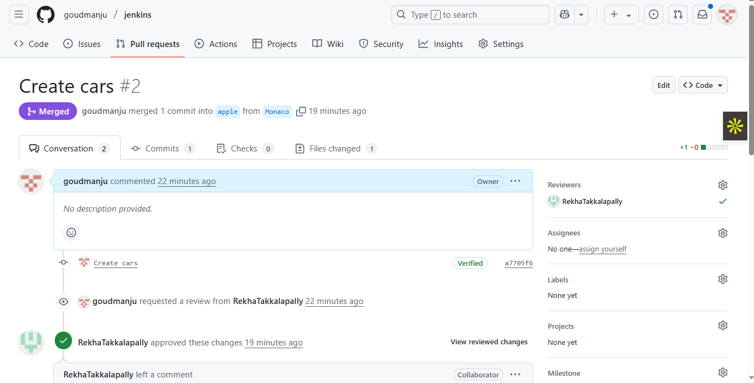

10)create a file in local and send that to branch in github.

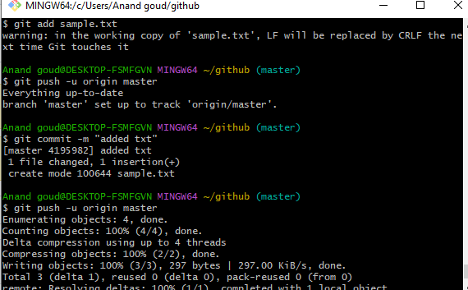

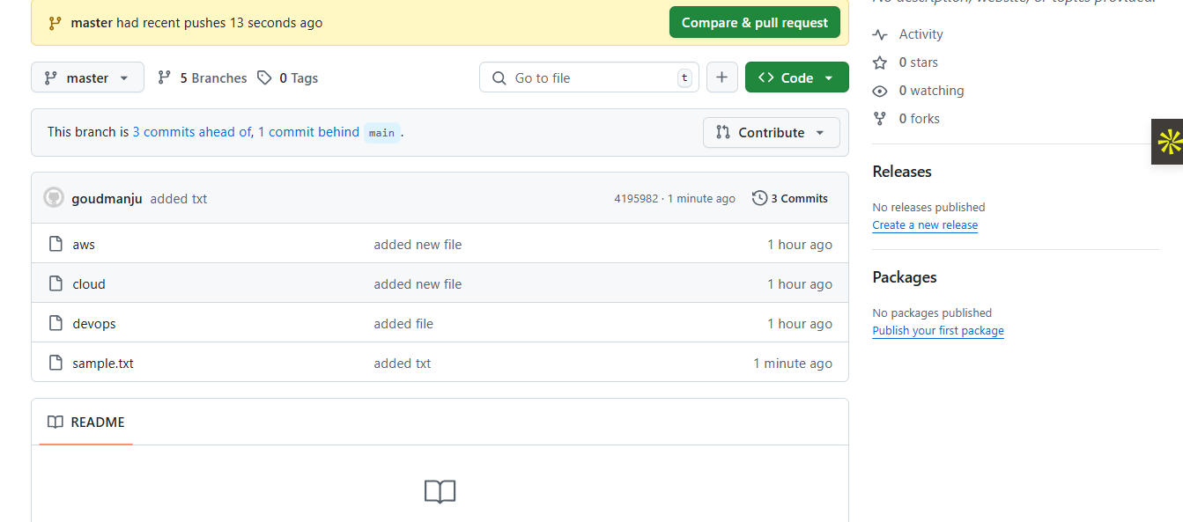

11)clone only a branch from github to local.

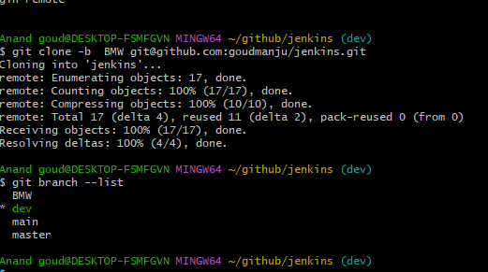

12)create a file with all passwords and make that untrackable with git.

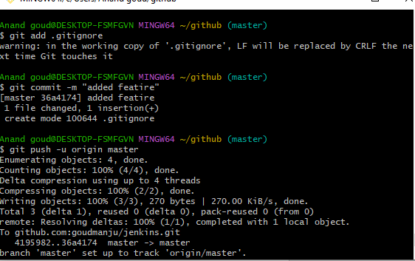

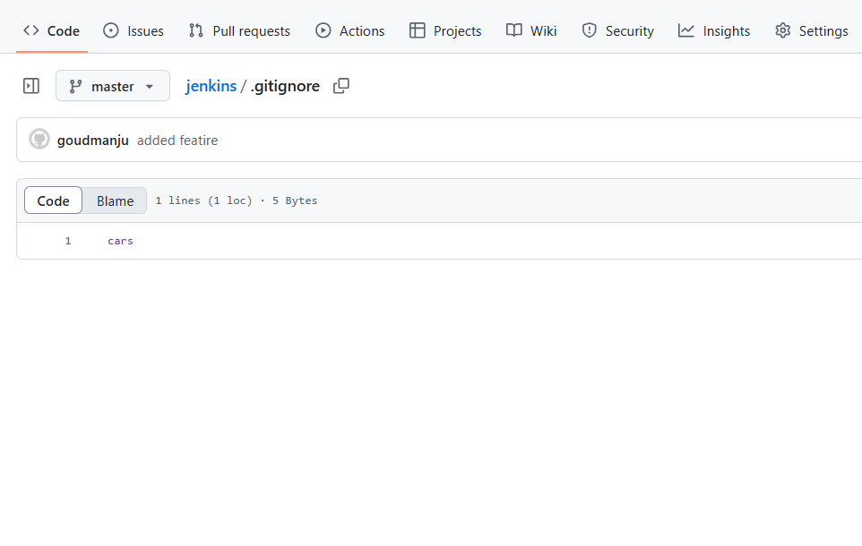

13)make a commit and make that commit reset without savings changes.

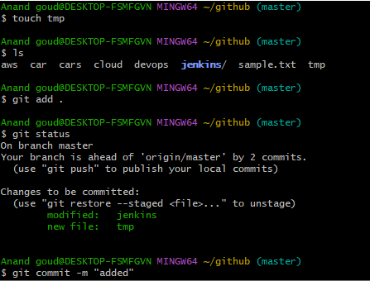

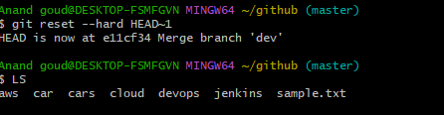

14)Revert a commited commit to the older version.

g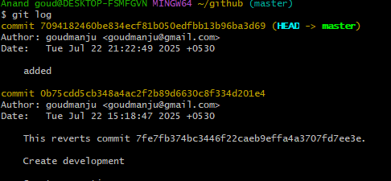before making changes in commits.

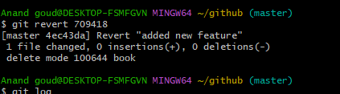

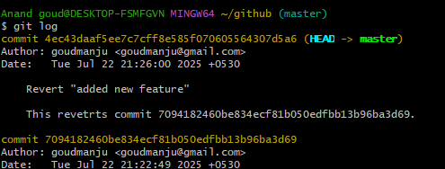after making changes in commits.

15)push a file to stash without savings the changes and work on another file.

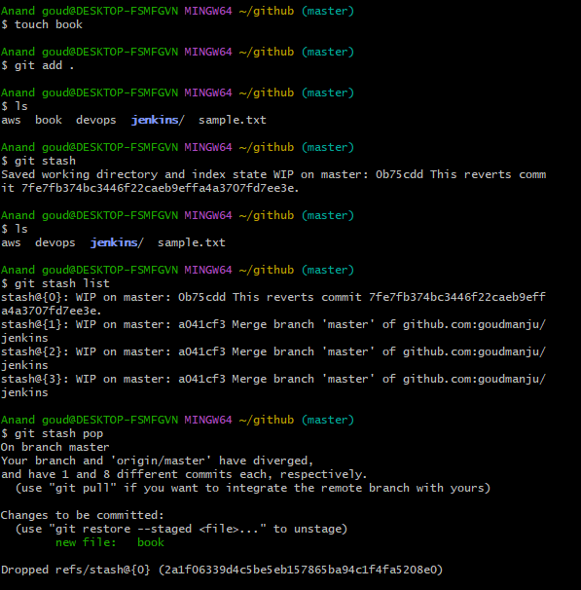

16)undo the stash file and start working on that again.

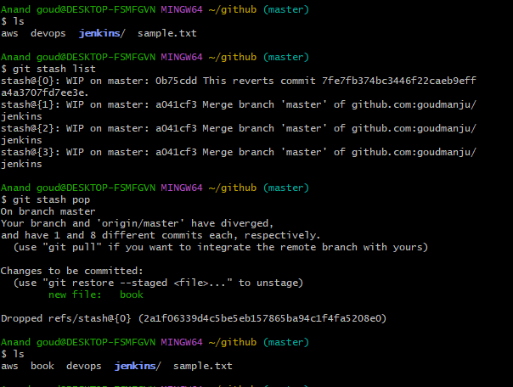

17)generate a ssh-keygen and configure into github.

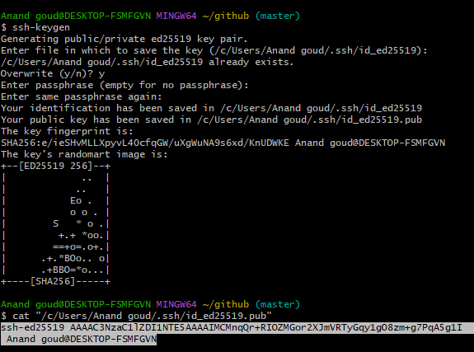

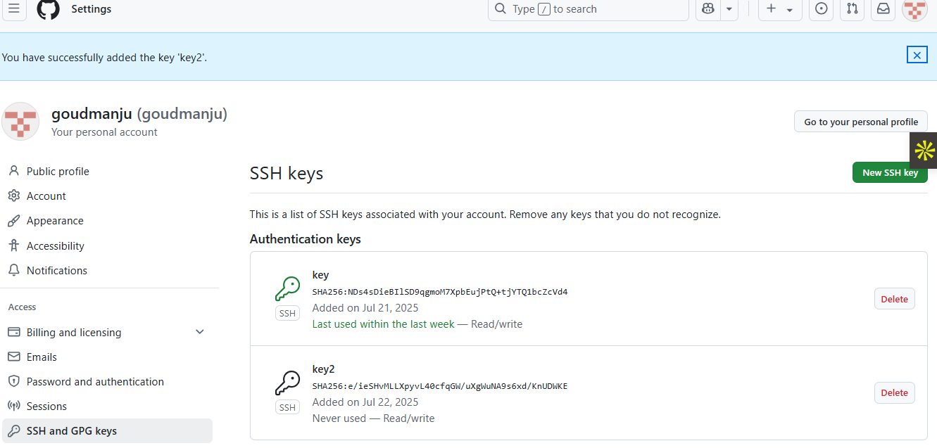

18)configure webhooks to github.

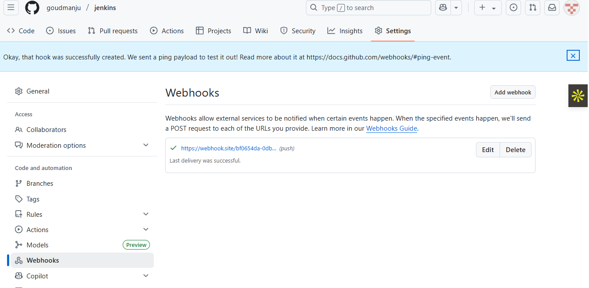

19)basic understanding of .git file.

The .git **directory** (often mistakenly called a .git file) is **the heart of any Git repository**. It contains all the metadata and history of the project.

* It's a **hidden folder** (because of the dot) created when you run git init in a project.
* It holds everything Git needs to track versions, branches, commits, and more.
* **DO NOT delete or modify it manually**, or you'll break the repo.

20)Check all the logs of git.

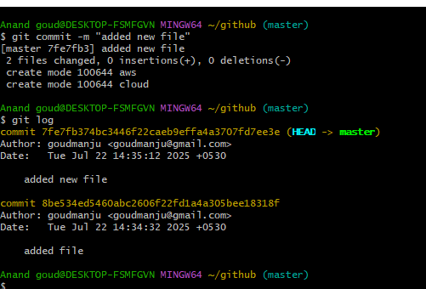

21)Rename the commit message.

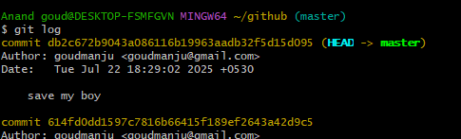

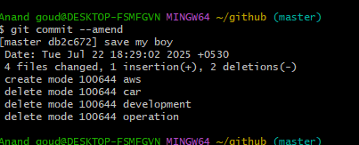

22)Merge multiple commits into single commit.

